First install MySql Service

C:\PHP\xampp\**mysql\mysql_installservice.bat**

Then the service is running, now work in the console to create databases, tables, you may start – stop the service with Control Panel / Administrative Tools / Services / MySql

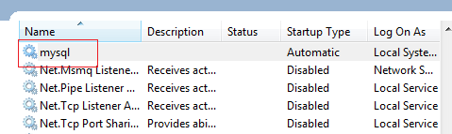

Once the service is running, create database and tables using the console in the command line

C:\PHP\xampp\mysql\bin>mysql –h localhost –u root – p

Enter password:

1. Since the root user does not initially have a password, hit enter when prompted for a password
2. You should then see the prompt **mysql>** in the command prompt
3. To exit type exit

The GRANT SQL command is used to create database users and grant them privileges

GRANT privileges:

ON objects

TO ‘username’ @ ‘hostname’

IDENTIFIED BY ‘password’

Objects is specified in the format **dbName.dbTable** where the wildcard character, *, can be used to either the database name or the table name

**DATABASES**

**In the command prompt**

* Mysql> CREATE DATABASE dbName;
* Mysql> SHOW DATABASES;
* MySql> USE dbName;

**TABLES**

|  |  |
| --- | --- |
| **DATA TYPES** | **Column Attributes** |
| * INT * INT UNSIGNED (only positive) * DECIMAL (Digits, decimals) * CHAR(size) * VARCHAR(size) * TEXT * DATETIME   **TO SET THE FORMAT FOR DATETIME USE date()** | * PRIMARY KEY * AUTO INCREMENT * NULL * DEFAULT |

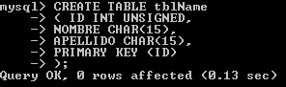

**With “;” you finish the command, DON’T FORGET “;” TO PROCESS COMMAND**

**AUTO_INCREMENT PRIMARY KEY**

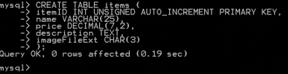

**To set a primary key from 2 fields**

**CREATE TABLE orders_items (**

**orderID INT UNSIGNED,**

**itemID INT UNSIGNED,**

**quantity INT,**

**price DECIMAL(7,2),**

**PRIMARY KEY (orderID, itemID)**

**);**

SHOW TABLES;

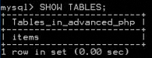

DESCRIBE <table>;

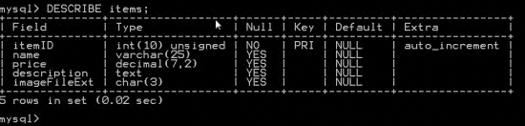

**IMPORTANT:**

WHEN INSERTING ROWS INTO A TABLE WITH AN **AUTO_INCREMENT** COLUMN

* SET THE VALUE ONLY FOR THE FIRST ROW, IN THIS CASE IS 1001
* FOR FURTHER INSERTS, THE VALUE IS ‘NULL’ OR ‘0’

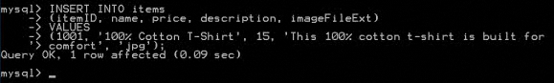



You can create a .sql file . Run the file with the name or

**mysql -u user - p pass databaseName < c:\file.sql**

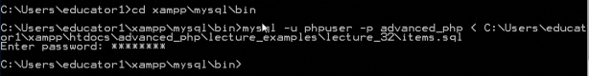

WHERE CLAUSE CAN USE

* Logical OR, AND, NOT
* Comparison =, !=, >, >=, <, <=
* LIKE

mysql> SELECT * from tutorials_tbl

-> WHERE tutorial_author **LIKE** '%jay';

**USING SESSIONS TO RESTRICT ACCESS**

As long as the session is still valid, the session cookie will provide a user’s request for each restricted page with access to the session data & thus the session variables

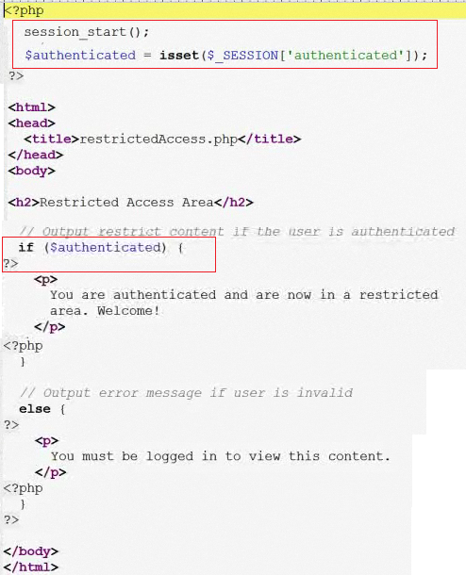

**Login**

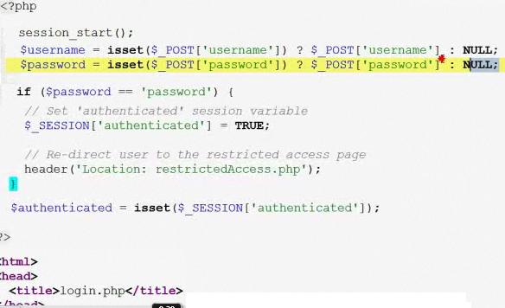

**Restricted**

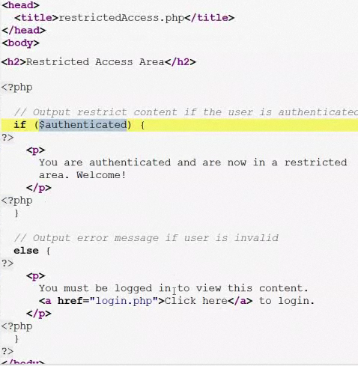

**Logout: Simply destroy a user’s session and any data associated with it**

**<?php**

**session_start();**

**$_SESSION = array();**

**/* Destroy session cookie ' ' (sin espacio) */**

**$params = session_get_cookie_params();**

**setcookie( session_name(),' ' , time() – 60*60, $params['path', $params['domain'] );**

**/* Destroy session data on the server */**

**session_destroy();**

**/* test if user is still authenticated */**

**$authenticated = isset($_SESSION['authenticated'] );**

**?>**

<html>

<head>

<titel>logout.php</title>

</head>

<body>

<h2>logout</h2>

**<?php**

**If (!$authenticated) {**

**?>**

**<p>You were successfully logged out.</p>**

**<p><a href=”login.php”>Click here</a> to log back in.</p>**

**<?php**

**}**

**?>**

</body>

**</html>**